UMW Speaking Center Presents
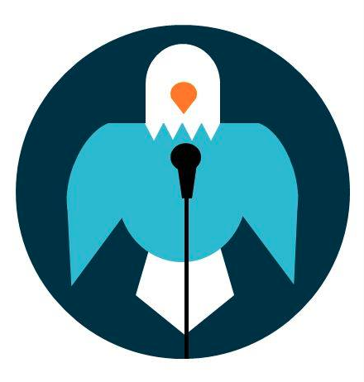
Effects of Body Language

How you present yourself can convey a lot to your audience. Here is a breakdown of how to recognize positive and negative body language. Negative body language can distract your audience or make you seem unprepared and nervous. Remember that your actions while speaking are most meaningful when you combine several positive gestures at the same time and when they are in line with what you are saying at the time you make them.

Positive Body Language | Negative Body Language
Body Posture  - Relaxed, steady stance and breathing  - No visible signs of stiffness or abrupt movements  Shows no communication barriers | Body Posture  - Body tense, stiff, or too casual and relaxed  - Hands clasped tightly or moving in abrupt motions, fidgeting  Shows distracting signs of nervousness
Arms  - Arms uncrossed  - Hands open with palms up or visible to others  Conveys openness | Arms  - Arms crossed or hands on hips  - Arms stiff or with hands in pockets  Conveys dominance, nerves, or disinterest
Eyes  - Look to all parts of the audience  - Avoid looking at visual aid for extended periods of time  Shows interest in audience | Eyes  - Focus only on one part of the audience  - Reading from notes with little to no eye contact  - Looking away from audience to recall speech  Indicates insecurity and lowers credibility
Demeanor  - Smiling at the audience  - Appropriate humor  - Expressive face  Signals warm relationship with audience | Demeanor  - Speaking in monotone  - Lack of facial expressions  Can turn audience away from your message
Proximity  - Appropriate distance between yourself and audience  - Clearly visible and engaging  Forms a relationship with audience, shows interest | Proximity  - Staying away from the audience or hiding behind a podium or in a corner  Creates a barrier between you and audience, indicates insecurity
Gestures  - Natural gestures with open palms  - “Talk with your hands”  Shows sincerity and enthusiasm | Gestures  - No gestures or stiff motions  - Over exaggerated or inappropriate gestures  Can form communication barrier or become distracting

If you want more information, check out the following UMW Speaking Center handouts:

What Should I Do With My Hands?
Posture and Body Stance

