UMW Speaking Center Presents
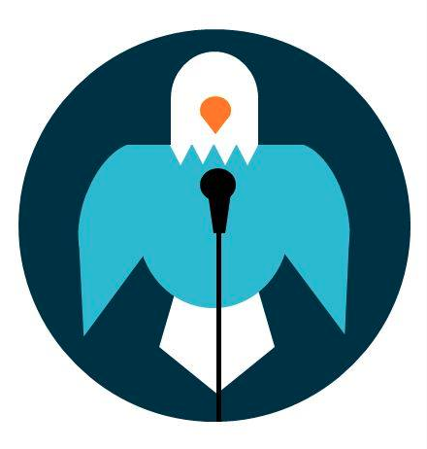
Tips for Preparing an Interview

- Dress professionally: Look professional and polished. It is important to look well-dressed and put together, regardless of the company you are applying to.

- Arrive early: If you don’t, you will make a bad impression before you even get to your interview. It shows poor time management skills and a lack of respect.

- Don’t bring a drink with you: It creates an opportunity for distraction, especially if it is something other than water. In addition, it is possible that you will create a spill.

- DO NOT use your phone during the interview or while waiting: Before you arrive, silence your phone. Do not use your phone once you enter the facility for the interview because it looks as if you are not completely focused or dedicated.

- Be Ready to answer the following questions:
  - Tell me about yourself.
  - What do you know about this company/position?
  - What is your biggest weakness?
  - Why do you think you are qualified for this position ?

- Know your resume!

- Be prepared to send a thank you note!

