UMW Speaking Center Presents
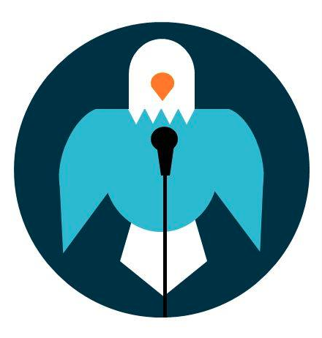
Speech Opening and Closing

TIPS FOR OPENING YOUR SPEECH
All speeches, no matter the time limit or formality, should have some kind of brief opening.

A good opening will always grab the audience’s attention, but shouldn’t necessarily “shock” the audience. Upsetting your listeners usually deters them from your message, and this technique should only be used in instances when it is essential to the speech.

Your opening sets the stage for the rest of your speech, so it should be strong. Memorize your opening, even if the body is extemporaneous. Work with it while you rehearse to make it fit your needs, but don’t stray from it when you give your speech, even if you think you have a better idea.

Good ways to open a speech:
- A startling fact
- An intriguing question
- A story
- A displayed object

Avoid opening your speech with:
- An apology
- A dull/commonplace observation
- A long or slow developing statement
- A trite question
- Unrelated information

TIPS FOR CLOSING YOUR SPEECH
All speeches, no matter the time limit or formality, should also have some kind of brief closing.

A good closing will indicate, along with your body language, that the speech is ending. It should effectively tie up your speech and reiterate your basic “take-home message.” Often, the closing will relate back to the introduction in some way, although it is not necessary.

The closing should also be memorized so that you begin and end with the same strength and confidence. Again, work with it while you rehearse and stick with your final product.

Good ways to close a speech:
- Summarize your points
- Relate back to your introduction
- Demonstrate what you talked about
- Appeal to the audience for action

Avoid closing your speech with:
- An abrupt ending
- New information
- Another viewpoint
- Phrases such as “And that’s all I have”

If you want more information, check out the following UMW Speaking Center Handouts:

Brief Guide to Constructing a Speech

Adapted from Stephen M. Fournier, http://stevefournier01.tripod.com/tips/tips-open.html with additions by the UMW Speaking Center, 2014

