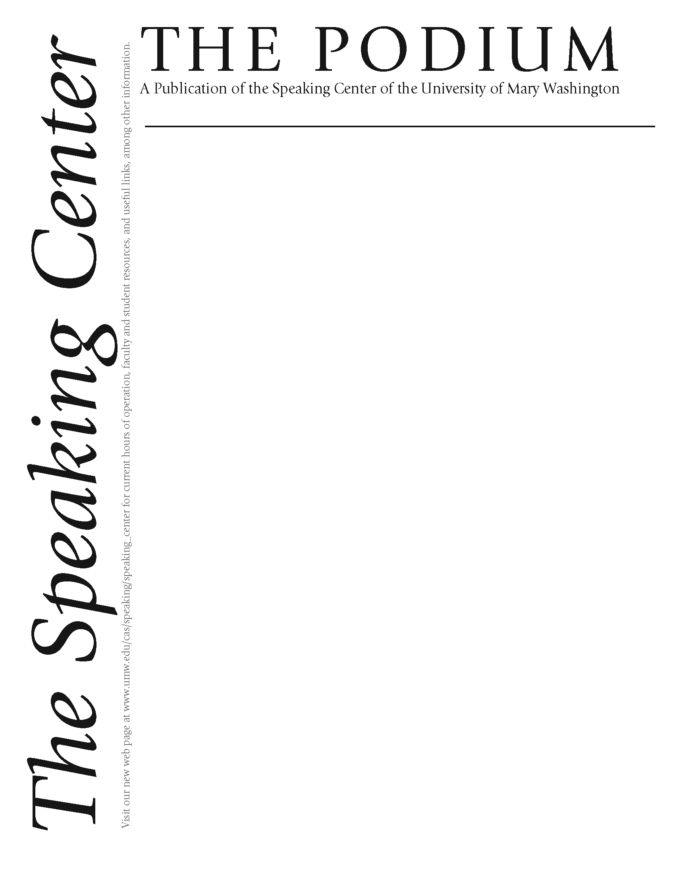

###### *Continued on page 2*

**Director’s Corner: It’s a Balancing Act!**



Volume 16 Edited by Catie LeBouton and Stacey Peros Issue 1, Fall 2012



As we are in the midst of a brand new semester of a brand new academic year, it’s worth noting that the theme for our All-day Retreat for staff on September 18, 2012 was “Balancing Innovation and Tradition.” The Speaking Center has been focusing on innovations to improve our jobs, consulting with computer science majors to create an ingenious scheduling and document-triggering software to make our job easier and more efficient. We also created the first automated Excel file version of the PRCA-24 (Personal Report of Communication Apprehension – 24 items) in the nation, getting permission from renowned communication scholar Dr. Jim McCroskey to use his survey. This survey, which assesses your level of apprehension in 4 areas (interpersonal, group, public speaking, meetings) can be used as a self-assessment tool and can be found on our website http://academics.umw.edu/speaking/speaking-center. We also hired 4 new consultants with diverse backgrounds to fill the positions of our 4 graduating seniors. Another novel aspect of the Speaking Center is that this year we are focusing on first year student outreach, as we know how important it is that students start to improve their communication skills early in their college years.

However, over the years we have worked hard to build a solid reputation for excellence in communication education. One professor, who sat beside me on the plane by chance on the way to the National Communication Association, used the word “guru” to describe our center. A professor at our own university commended the Speaking Center for the consistently well-trained staff that we produce. Our alumni continue to do well after graduation, using communication and professional skills honed on the job while at Mary Washington to go to law school, become teachers for Teach for America, and more. We will focus on continuing that tradition at our university, delivering our best service so that our students can communicate well and contribute to society. That is our mission, and that will remain constant throughout the innovations and changes over the years. We hope that you will visit the Speaking Center soon, to see the balancing act in person!

Esther Lee Yook, Ph.D.

Speaking Center Director

With the fall semester off to a quick start and presentation deadlines looming, a panic sets in for many students. Public speaking can be at best intimidating and at worst terrifying. However, it doesn’t have to be either. The Speaking Center offers one-on-one assistance with student consultants for those dreaded presentations. And if you don’t want to come in for a scheduled appointment, you’re in luck.

Every semester, the Speaking Center offers a series of workshops that are open to all students who want to learn more about the Speaking Center and better their communication and presentation skills. This month, during our annual Octoberfest, we will host three workshops: “Speech Basics,” “Presenting in a Foreign Language” and “Persuasive Speech.”

“Speech Basics” will take place on Tuesday, October 9th and is perfect for students who are seeking an overall introduction to public speaking. It will offer an overview of attention-getters, speech structure and speech delivery. The workshop on Thursday, October 18th, “Presenting in a Foreign Language,” is geared toward a narrower audience, and will focus on ways to develop confidence and skill while speaking in a foreign language. Our final workshop, “Persuasive Speech,” will take place on Monday, October 22nd and will offer tips for effective persuasion.

All workshops will take place on their respective dates in Combs 101 at 5:00 pm, and they will be catered. We look forward to seeing you!

###### *Continued on page 2*

**Fall 2012 Workshops**

# ***By Danielle DeVille***

New Ideas *continued from page 1*

**Director’s Corner** *continued from page 1*

New Ideas *continued from page 2*

Workshops *continued from page 1*

**What’s New at the Speaking Center?**

***By Abbie Boaduwa Yirrah***

Every semester, the Director of the UMW Speaking Center, as well as the consultants, remain committed to upholding the name of the Speaking Center in high esteem. We have a reputation to protect, and our main goal is to make ourselves accessible to UMW students in whatever way we can. This semester kicked off with an all day retreat that urged us consultants to keep to the tradition of the Speaking Center while being innovative as well. This can be a pretty difficult challenge. How do you introduce new methods and ideas while sticking to a long established custom that has been passed on from one generation of consultants another? To us, this meant sticking to the traditions that have proven effective over the years, while being open minded to new ideas. This also meant we had to be creative in our thinking and develop new methods of consultating. Most importantly, we have been challenged to avoid the cookie cutter method of handling our tasks.

While it was hard to let go of the four consultants who graduated in the spring, the Speaking Center is very fortunate to have replaced them with equally exceptional new consultants who are also dedicated to bringing their expert advice into consultations and helping students become better public speakers. The Speaking Center is very fortunate to have student consultants with very diverse majors who are engaged in various activities on campus and acquainted with the needs of UMW students. Consultants, Rob Belcourt and Stacey Peros, have transitioned well into their roles as lead consultants and are leaving no stone unturned when it comes to the affairs of the Speaking Center. Our Octoberfest activities are about to kick off and because we are a team that firmly believes in the spirit of team work, each consultant has volunteered to take up a task to ensure another successful Octoberfest. Our semester workshops have also been successfully planned out and we are eager to see students attend.

We are also excited about the future of the Speaking Center. In the next couple of years, we will relocate to the Convergence Center where there will be a lot more space for students to interact and more consultation rooms. We are proud to say the Speaking Center is experiencing one of its best years ever. The spirit of love, teamwork and dedication can be sensed immediately when one walks onto the premises. We look forward to meeting and working with the first year students, continuing the good work we’ve been doing with the upperclassmen, and offering our services in whatever way we can to the UMW community.

**Connecting Cultures through Public Speaking**

***By Stacey Peros***

This was especially the case for one of my public speaking classes in Tuzla. One week, students from Doboj were provided with free transportation to Tuzla to attend classes. As a result, I had a completely mixed public speaking class. The class consisted of ethnic Muslims, ethnic Serbs, and ethnic Croats. This would often lead to rude remarks in most cases in Bosnia-Herzegovina, but not in this class. In fact, it became my favorite class while teaching there. Each of the students was enthusiastic, and each student brough his or her unique personality to the class. Their presentation topics were excellent. Through their presentations, I learned about everything from the education system in Bosnia-Herzegovina to science to literature to Bob Marley. But most importantly, the students had fun. They gained new friends of different ethnicities. There was contagious laughter in the classroom. One student would tell a joke, another would start laughing until there were tears in her eyes, and it would create a domino effect with all of the other students. There were even times when students had to come in from the other classrooms to make sure everything was okay, since we were laughing so hard. Overall, it was a heart-warming experience to see students of different ethnicities enjoying their time together and being connected through a public speaking class.

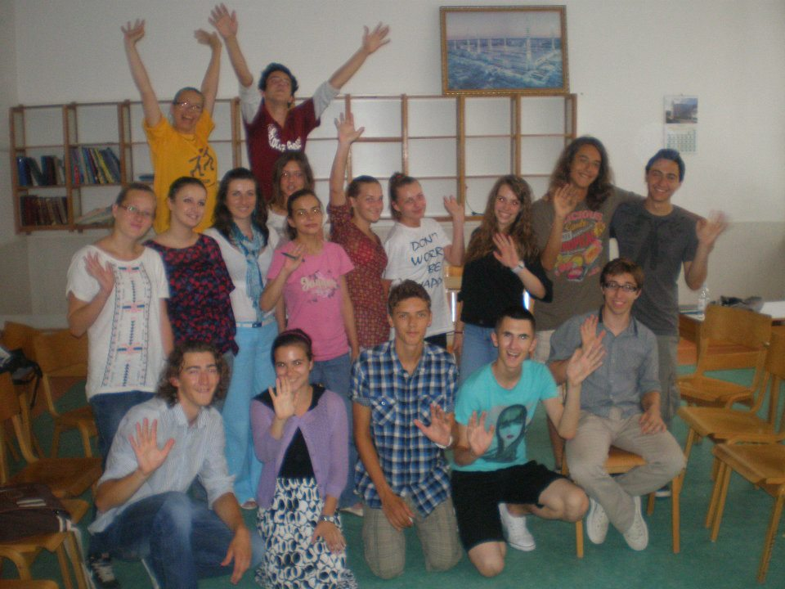

For most of my time at the University of Mary Washington, I have worked at the Speaking Center. Even when I did not work during my first semester of freshman year, I still had to go for my Public Speaking course. During my stay at the Speaking Center, I developed the ability to teach public speaking. Little did I know that this new skill would take me abroad and allow me to share my knowledge with a people close to my heart.

This summer, I received the opportunity to be an intern for a non-governmental organization called Bosnia Initiatives for Local Development (BILD). The internship took place in Bosnia-Herzegovina, which meant a lot to me, as my parents were born in neighboring Croatia. I understood that the region has struggled, with education being one of the greatest areas of difficulty. Among other things, I taught public speaking at the Tuzla and Doboj Summer Institutes, which are both part of BILD’s education projects. The students in this program were at the high school and university levels.

Many Americans are unfamiliar with Bosnia-Herzegovina, so it is important to note that Bosnia-Herzegovina is still divided upon ethnic lines. The two main political divisions of Bosnia-Herzegovina are the Federation (which mostly consists of the ethnic Muslims and Croats) and Republika Srpska (which mostly consists of the ethnic Serbs). The two cities where I taught in are located on opposite sides: Tuzla is located in the Federation, while Doboj is located in Republika Srpska. One of the main goals of the summer institutes was to cross entity lines by having students from Tuzla participate in the Doboj Summer Institute and by having students from Doboj participate at the Tuzla Summer Institute.

While I supported this idea in theory, I was a little bit hesitant as to if it would actually work in practice. While the war in Bosnia-Herzegovina is long over, there is still an internal conflict among the different ethnic groups of the country. However, I was surprised to see this idea come to life during my time there.

Dylan is a junior and a political science major at the University of Mary Washington. He is excited to be working at the Speaking Center this year as a consultant and technician. He enjoys playing guitar, hanging out with friends, and participating in swim club.

Meet the New Consultant: Dylan Drury!

*Continued on Page 5*

Public speaking isn’t always just about speeches and formal presentations. In fact, most of our communication skills in the classroom come from another realm entirely—class discussions. Leading a discussion can be a somewhat intimidating task. How do you get people to talk? What are some ways to facilitate a meaningful conversation? What if no one has anything to say? Here are seven helpful hints to guide you as you prepare to lead your class in a lively and inclusive discussion:

**Be Open with Your Questions:** Make sure you avoid posing any question that can be answered “yes” or “no.” A question that seems to have a correct answer doesn’t lend itself to discussion; it can make others second-guess themselves and shut down what might have been a great talking point. Instead, try to ask questions about reactions, perceptions, and even emotions. From there, you can take the discussion more in depth.

**Avoid Answering:** It’s tempting to jump in on the conversation yourself, but be careful about how often you do it. The leader will never have all the answers, so be sure to let the class put in their two cents. In fact, be proactive and *encourage* them to react to their

**Communication in the Election**

***By Mariah Young***

As the prediential election nears, the media has started to increase the amount of coverage on both candidates. Not only is communication important to how the media portrays the candidate, but also to how the candidate portrays himself. With every word either candidate speaks, the media has the opportunity to put a bias on how it reports the statement.

The one chance the candidates have to truly and openly communicate with the public is the presidential debates. Debates allow for candidates to rally the base, get their already assumed voters to vote, and gain a few swing voters. While some political scientists do not believe the debates will drastically change this election, it will give each candidate a chance to clarify their position. Debates have rarely been proven to turn an election, and this one does not seem like it will either, but it can and probably will affect how the voters see each candidate.

The best way to establish a good communication with the public is to speak directly to them. The purpose of these debates will be just that. The goal of the candidates should not be to bicker back and forth, but instead to explain why their policies and platform are better for our country. It is not a time for the political parties to bash each other; instead it is very formal and polite. While the media and political parties make statements against each other constantly during the election season, the actual debate will be something out of the ordinary.

Each candidate will have effective ways of communicating his policies to gain more voters on certain issues. Unless you watch the event, you will probably get a media analysis afterwards, which is nothing compared to the actual event. The newspaper headlines the next day do not provide the same sense of communication as that of the actual debate, as you watch each candidate ask you for your vote in this very important election.

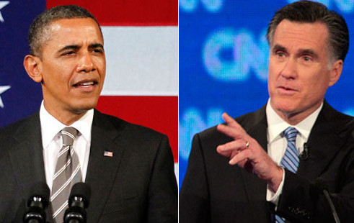

**Leading Class Discussions**

***By Catie LeBouton***

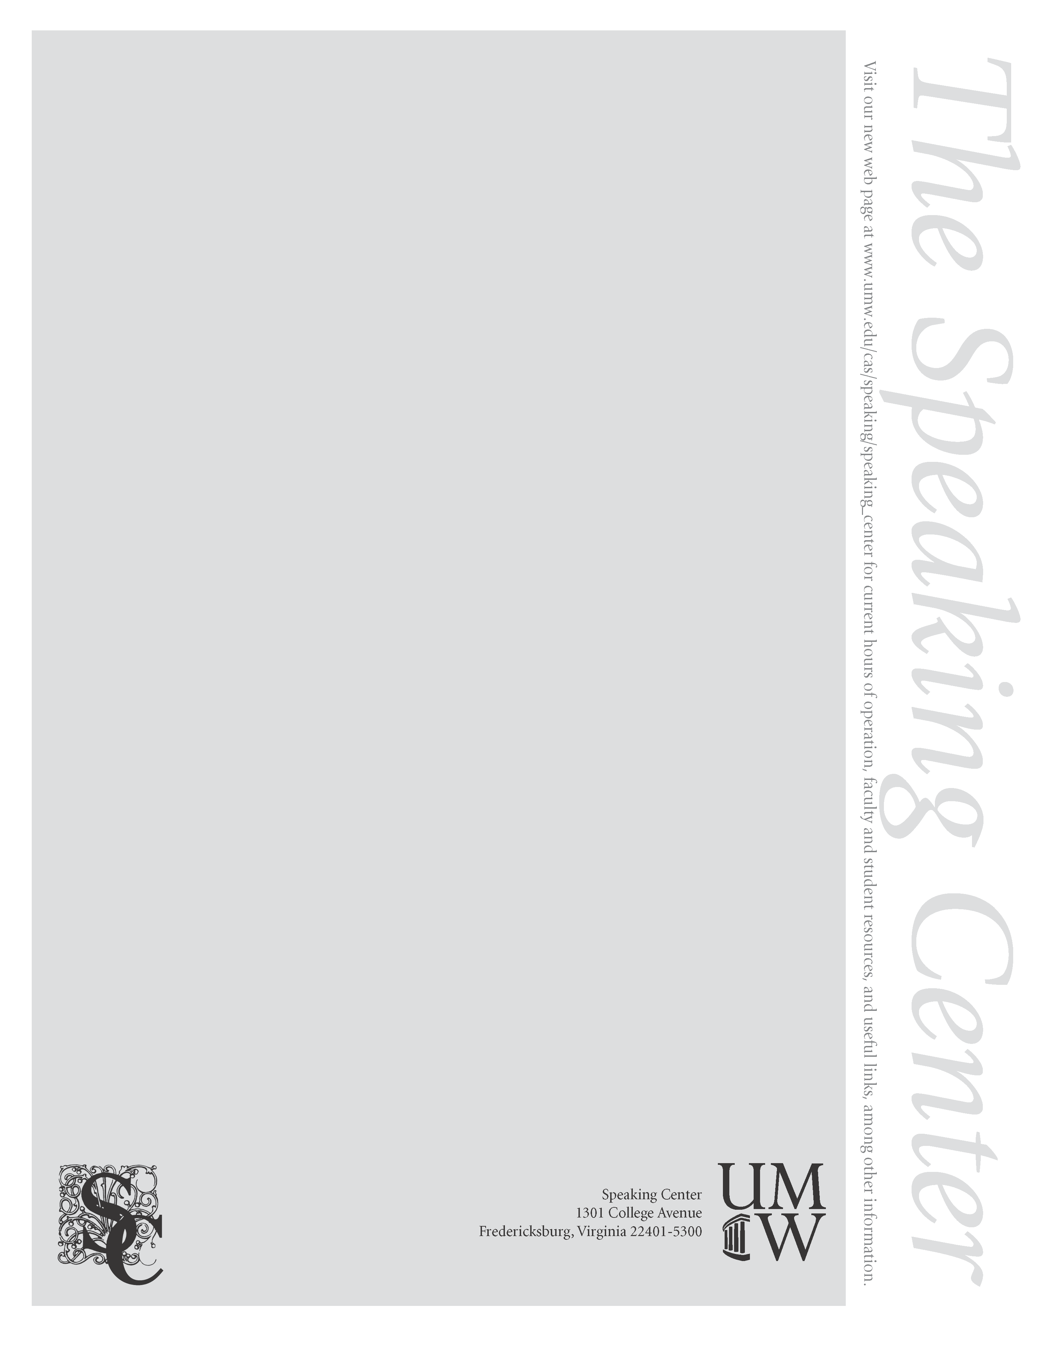

their classmates’ statements. They could bring up something you never even thought of!

**Allow Questions:** Similarly, you should encourage others to *ask* questions: about the topic you’re discussing, about what another classmate said, or about relevant information that just needs to be cleared up. Just because you’re leading the discussion doesn’t mean it has to be one-sided.

**Be Flexible!:** When good questions are asked, your organized discussion can easily take turns you didn’t expect. If the class starts talking about a point you hadn’t reached yet, let them. Don’t be afraid to deviate. Also, if one topic gets stale, change it to one that hasn’t been explored and see if you can’t spark a new response. If you stay on your toes, your discussion can easily be lively and enjoyable!

**Embrace the Pause:** Give the class some time to think over what’s been said. An awkward silence is only as awkward as you make it. Rephrase the question, offer up a general idea, and see if you can’t reach someone in your audience. Remember, you’re in charge. If people still aren’t talking, go ahead and call on someone. If they don’t understand a concept, ask why. Opinions are answers, too.

**Give Everyone a Chance:** Sometimes, you’ll get that one student that seems to have something to say about everything. Be sure you recognize people who haven’t spoken yet over those who have. Don’t ignore them, of course, but be aware that fresh perspectives are always welcome. Chances are, your active participant will have another comment or counter-argument to keep the conversation going!

**Make it a Positive Interaction:** Above all, be an inviting leader. Smile, nod, look the speakers in the eye—let them know that what they’re saying is important. By making them feel welcome in the discussion, they may be more willing to open up even more later on. After all, without their input, there’s no discussion at all!

**Class Discussions** *continued from page 4*

*Continued on page 6*

Recently, our reputation for giving good advice has grown to the point where people are writing to us, asking for speaking advice in everyday life. Russell, one of our most experienced consultants, has gladly answered the call.

***Dear Russell,   
  
I haven't been doing too well here and I need to tell my parents that I've just been put on academic suspension. Do you have any tips on how to break the news to them?  
  
From,  
Greg***

***Greg,***

Breaking bad news to parents is never fun. Luckily, there are delivery tips I can give you that will help soften the blow. Before you can start thinking about how you're going to say what you're going to say, you need to think about your appearance. Given the casual setting, you shouldn't have to dress up, but don't take that too far and dress like a bum. Also, be sure to stand up straight. Slouching can suggest laziness and you definitely don't want to make that impression.   
  
 Make sure you demonstrate consistent eye contact throughout your presentation. The fact that you're able to look your parents in the eye is a sign of maturity. Also, try not to sway or have any distracting movements. These can portray you as uncomfortable, which may in turn make your parents feel uncomfortable. Most importantly, you should add what we call in the biz “variation to your pitch.” By that, I mean try not to be monotone. If you are, your audience may not be convinced by whatever you say because it will sound overly rehearsed and/or disingenuous.

Best of luck,

RM

Ask a Consultant!

***By Russell Michelson***

So what should you expect when you come to the Speaking Center? First, know the location. The Speaking Center is in Combs 101 – in the corner on the first floor. A consultant will greet you when you enter. They will take you back into one of our consultation rooms, where you can prepare for whatever you came to the Speaking Center to do. You can pull out a notebook if you requested a brainstorming session, or you can load your Powerpoint if you are presenting a speech. Always remember to bring a syllabus/rubric with the expectations for the assignment – that gives us exactly what we need to know to best help you.

When you come for a brainstorming session, it will generally last thirty minutes. Within those thirty minutes, you can ask us any questions about the substance or delivery of your speech. We will give feedback on your thinking about how you will present, or we may ask you questions so that you can come to new conclusions about how or what to present.

For a practice session, the length of the speech determines the length of the session. When you decide to come to the speaking center, remember to bring your Powerpoint or any other visual aid you may have. We will watch you present, and we even have the ability to record you so you can watch yourself. Then we give you feedback based on what we saw in an attempt to guide you in thinking critically about your presentation. This is why being recorded is helpful – you can see what we are talking about. We also give feedback about your visual aids and how you are using them. You may have a great Powerpoint, but the animations may make it less professional. We will let you know our thoughts, and hopefully we can provide you a fresh perspective that makes you think.

At the end of the feedback period or brainstorming session, we will ask you for feedback based on responsiveness to your needs. Then, we send an email to your professor simply detailing what occurred during the consultation. The notification we send is not graded. It lets your professor know that you came to the Speaking Center – your extra effort is valued by professors. You also receive a copy of the notification so that you can remember what was discussed during the consultation. We hope we at least made you more comfortable presenting and that you had a pleasant experience in the Speaking Center; you may even find that you receive a better grade on your presentation as a result of your visit. Don’t just take my word on this – stop by the Speaking Center to discover for yourself!

Welcome to the Speaking Center, where it is all fun and games. Well, sort of. For us, each presentation is a unique experience where we learn and interact with someone. It may be someone we don’t know at all, or we may learn new things about old friends. People are welcome to stop by for a mint or to practice an hour-long presentation. We are always excited for a student to come, and we want the student to be excited too.

A Walk Through the Speaking Center

***By Tom Pacheco***

**Ask a Consultant!** *Continued from page 5*

***Dear Russell,***

***There’s this boy that I really like, but I don’t know how to tell him. Can you help me out?***

***From,***

***Jeanie***

Jeanie,

This situation calls for a good ol' fashioned persuasive speech.When you approach him, the first thing you’re going to want to have is an effective attention-getter. Say something like, “I have something important to tell you,” or “There’s something I’ve been meaning to tell you.” This will guarantee you have his full attention. Next, tell him your thesis statement and preview statement. Perhaps, “I really like you, and by the time I’m done talking, I hope you will want to go on a date with me.”

Now comes the bulk of your presentation, where you lay out two to four points trying to persuade your crush to go out with you. For your conclusion, make sure you summarize all your points and for this particular situation, I’d recommend inserting what we call in the biz a “call-to-action,” which would be actually asking him to go out with you. If you follow these steps, there’s no way he can say no.

Good luck!

RM

For free advice for any speaking occasion, come to the Speaking Center in Combs 101.

J A A I C M E T T Q R K C Q F O L F E X

G U S P Y Z N U D Z C O R C L C B F F T

Q H C I P O T E A P M L C I U B F R M J

C P A B B O N C J M T L N R W E U V Q D

Q D G Z R L I J U Z R N T O C S G E W N

Q N E O X A F N H D O Q R T R Z X W O U

N N K B J V I T T O S K I E P S C J X A

O P O C G C Q N J M S V P H E T I D S Z

I D H W A Y I I S H E T M R H Y I R C S

T P J T U N S O O T F N U K A F W C R B

A U I H N M T P W F O I T P Y C R Y M Q

T O G E S T U R E S R R N E D P T T C S

N M Y D Y B O E W A P R M P R E Z I N J

E H X S L P D W J G K B P K I M B Q C I

S A F I X B N O L H V I Y X Q Y T A Z E

E M C W A U A P T R X Y N Q F X H S T Y

R A Y C G B H T U Y N A W G U Z Q C T E

P K K P U I W T X M C G B G O Y U R N S

N P G H B U W L U L Q C H Y H W G R W H

S N D R K T W G K Y F S Q L K L A D A Q

ANXIETY PRACTICE

APPOINTMENT PRESENTATION

BRAINSTORM PREZI

COMMUNICATION PROFESSOR

DEBATE PUBLIC

EFFECTIVE RHETORIC

EYES SPEAKING

FEEDBACK SPKC

GESTURES TOPIC

HANDOUTS TUTOR

POWERPOINT WORKSHOP

**Speaking Center Word Search!**

# ***By Robert Belcourt***