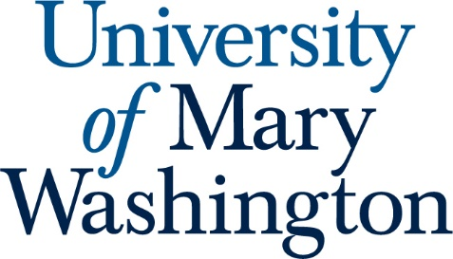

Student Learning Outcomes for Political Science

- Students will understand of American national institutions.

- Students will understand political life in Europe.

- Students will understand principal categories of political analysis.

- Students will appreciate the nature of systematic inquiry.

- Students will understand democratic/pluralist models.

- Students will understand principal theories of international relations.

- Students will understand principal ideas of major political theorists.

- Students will have facility in discipline-specific written communication.

- Students will maximize the program's advantage based on the location of the university and active faculty.

