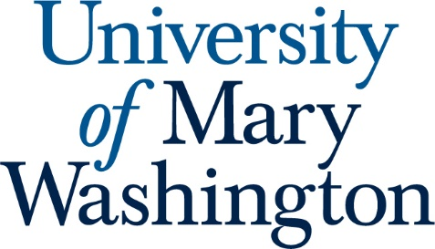

Student Learning Outcomes for

Modern Languages: French, German, Spanish

- Students will use language to engage in meaningful exchanges, to understand and interpret spoken language and written text, and to present information, concepts and ideas.

- Students will frame, analyze, and synthesize information as well as negotiate meaning across language and culture in order to explore problems and issues from their own and different perspectives

- Students will evaluate literary works in order to understand main themes and movements.

- Students will respond to new perspectives in order to understand diverse cultures within the world of a specific language.

