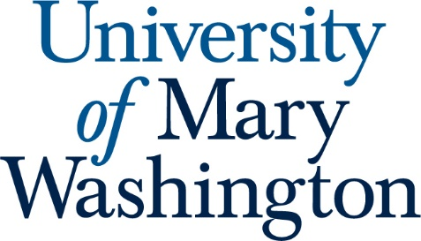

Student Learning Outcomes for International Affairs

- Students will understand principal categories of political analysis.

- Students will understand issues in European diplomacy.

- Students will understand principal economic consequences of issues in international trade.

- Students will understand principal geographical concepts and issues in world politics.

- Students will understand the concept of the balance of power.

- Students will maximize the program's advantage based on the location of the university and active faculty.

- Students will appreciate the nature of systematic inquiry.

- Students will demonstrate facility in discipline-specific written communication.

- Students will understand the principal theories of international relations.

