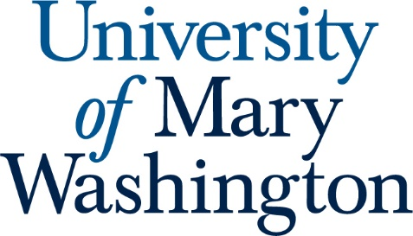

Student Learning Outcomes for Classics

- Students will demonstrate general knowledge of the outlines of Greek and Roman history, culture, and literature.

- Students will engage with the culture, literature, research, methods, and scholarship of the discipline.

- Students will develop competencies in reading Latin and ancient Greek.

- Students will demonstrate effective oral and written communication skills.

- Students will present, analyze, interpret, and synthesize evidence and scholarship on a topic relevant to classical or ancient Mediterranean civilization.

- Students will create an original argument or creative work supported by individual research on a topic pertaining to classical or ancient Mediterranean civilization.

